North Korea vs. the World
This brutal, isolated Communist nation continues to test nuclear weapons and threaten its enemies, including the U.S. Can North Korea be stopped before it’s too late?
By: Rebecca Zissou February 20, 2017
Fifteen-year-old Joseph Kim was living on the streets of Hoeryong, North Korea, alone and afraid. His father had died of starvation years earlier, and his mother and sister had disappeared without a trace. Instead of going to school, the teen spent his days searching for food or working odd jobs.
Fearing that he wouldn’t be able to survive for much longer in North Korea, Joseph decided to try to flee the country. He knew that if he were caught attempting to leave without the government’s permission, he could be arrested and even put to death.
“I knew the journey would be risky, but I would be risking my life either way,” Joseph said later. “I could die of starvation like my father in North Korea, or at least I could try for a better life by escaping to China.”
So in the middle of winter, Joseph left his hometown with little more than the clothes on his back. Careful to avoid armed border guards, he ran across the frozen Tumen River into China. Within months, he connected with an international aid group called Liberty in North Korea that helped him move to the U.S. as a refugee. Today, 10 years later, Joseph is a college student in New York.
In recent years, tens of thousands of people like Joseph have managed to escape from North Korea. The nation is one of the most brutal and isolated places on Earth. Its 25 million citizens are cut off from the outside world and have few rights or freedoms.
The country’s young ruler, Kim Jong Un, has been extremely aggressive and unpredictable, threatening North Korea’s enemies, including the U.S. and South Korea. Last September, he defied the world by testing a nuclear bomb. Then in a speech on January 1, Kim said his country was preparing to conduct its first test of a long-range missile, which could reach the U.S.

Testing Nukes
National security experts say the acceleration of North Korea’s nuclear program is a serious threat to the U.S. and its allies in Asia, particularly South Korea and Japan. A single nuclear bomb could wipe out an entire city and kill millions of people. Nine countries possess nuclear weapons—including the U.S. But North Korea is the only one to have tested them in the 21st century.
To prevent North Korea from perfecting a nuclear weapon, the U.S. and the United Nations (U.N.) have had a series of sanctions in place for years. Those penalties aim to restrict international trade and make it harder for the North to fund nuclear research. Sanctions have also made daily life harder for ordinary North Koreans, but so far, the measures haven’t been effective in persuading Kim to return to the negotiating table.
Beatrice Fihn of the International Campaign to Abolish Nuclear Weapons says the world needs to act now to prevent Kim from expanding his nuclear program. North Korea’s latest test “should be an urgent wake-up call” for the world, Fihn says.
North Korea’s troubled history with the U.S.—and its neighbors—goes back to the end of World War II (see timeline, below). In 1945, the Korean Peninsula, which had been occupied by Japan since 1910, was divided into two zones.
In 1945, the Soviet Union occupied the northern zone and installed a Communist regime, led by Kim Il Sung (Kim Jong Un’s grandfather). Meanwhile, South Korea—the zone that had been controlled by U.S. and Allied forces—became a democracy and an important U.S. ally.

The 38th Parallel
In June 1950, North Korean forces invaded the South, starting the Korean War. An international coalition led by the U.S. came to the South’s defense. Three years later, an armistice ended the conflict. By that time, about 3 million people had been killed, including 34,000 U.S. soldiers. The agreement established a 2.5-mile-wide demilitarized zone (or DMZ) separating North and South Korea at the 38th parallel (see map). The armistice was supposed to be temporary, but a formal peace treaty has never been signed, and the two Koreas remain technically in a state of war.
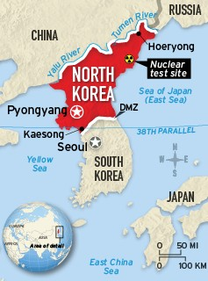
After the war, North Korea and South Korea moved in opposite directions. Today, the South has the 13th-largest economy in the world. It’s also a major exporter of cars and electronics and is home to some of the world’s most successful brands, including Samsung and Hyundai. The North, on the other hand, became one of the most isolated and repressive regimes on Earth.
The Kim family has ruled North Korea for three generations, maintaining tight control over the nation’s government and its people. At times, the country’s state-run economy has struggled to provide enough food to feed its citizens. In the 1990s, a series of droughts and floods contributed to a widespread famine that killed tens of thousands of people. Some North Koreans, including Joseph and his family, resorted to eating weeds and bugs.

Young & Ruthless
In 2011, Kim Jong Un inherited the dictatorship after the death of his father, Kim Jong Il. At the time, there was hope that the young leader would modernize the country and improve relations with the world.
But he’s proved to be just as ruthless as his father and grandfather. In 2013, Kim even ordered the execution of his uncle—his second-in-command and mentor—for allegedly plotting to overthrow him. Kim has also continued to test missiles and threaten the U.S. and South Korea with nuclear strikes.
Today, millions of North Koreans live in poverty. Many homes lack indoor plumbing and rely on fireplaces for heat. Few paved roads exist outside of major cities, and shortages of water and electricity are common.
Daily life is also strictly controlled. Ordinary citizens have little to no access to the internet, and TVs and radios receive only government channels. Homes are equipped with loudspeakers that blare state-sponsored propaganda all day long—and can’t be turned off. At school, North Korean children are taught to be loyal to the Kims and to worship them like gods.

Labor Camps
In fact, anyone who challenges the country’s leaders can be arrested and forced to work in labor camps. A 2014 U.N. report estimated that up to 120,000 political prisoners are kept in four crowded camps. Experts say starvation and other forms of torture are routinely used to punish prisoners.
At the same time, the government spends billions of dollars maintaining a massive army of 1 million people—among the largest in the world. Elaborate military parades often take place in the capital, Pyongyang, as a show of strength. The North also pours huge sums of money into developing nuclear weapons and ballistic missiles, which it sees as the only way to ensure its survival.
Some experts now say that North Korea’s nuclear capabilities may be more advanced than we think. The U.S.-Korea Institute in Maryland recently concluded that the North will be able to build a missile capable of striking the United States by 2020.
After the latest nuclear test, the United States and the U.N. passed new, tougher sanctions. The U.N. and the U.S. hope that further weakening North Korea’s economy will prevent it from being able to finance its nuclear program. The U.S. also plans to install a missile defense system in South Korea that could shoot down the North’s missiles.

‘A Lost Cause’?
President Trump has said that he’ll apply economic pressure on China, North Korea’s closest ally and trading partner, to force it to rein in its neighbor. He’s also suggested that South Korea and Japan do more to defend themselves against North Korea and not rely so much on the U.S. Additionally, Trump has said that he’s open to meeting with Kim to try to convince him to end his country’s nuclear program.
Some experts, however, are skeptical that Kim will ever abandon nuclear weapons. Last fall, then-U.S. intelligence director James Clapper said it was “probably a lost cause.”
But other experts are more hopeful. Jenny Town of the U.S.-Korea Institute says resuming long-stalled talks with North Korea would be a step in the right direction. Negotiating an end to North Korea’s nuclear program is sure to be “a long-term process,” she says. “But it is possible.”

TIMELINE
1945: A Country Divided
At the end of WWII, Korea is divided, with Soviet troops occupying the north and U.S. troops in the south. The division is initially intended to be temporary.
1953: Korean War
34,000 Americans and more than 2 million Koreans die in the 3 year conflict. The war ends in a stalemate. An armistice stops the fighting, but no formal peace treaty is ever signed.
1995: Famine
While South Korea’s economy is booming, North Korea suffers a severe famine when its state-run agricultural program can’t produce enough food. Hundreds of thousands suffer from severe malnutrition, with thousands dying of starvation.
2006: Nuclear Tests
North Korea tests its first atomic weapons despite efforts by the U.S. and the U.N. to prevent it from becoming a nuclear power.
Today: Growing Aggression
When Kim Jong Un inherited control from his father in 2011, there were hopes he would mend relations with the world. But he continues to threaten other nations, including South Korea and the U.S., and has accelerated a push to develop nuclear weapons. President Trump has promised to get tougher with North Korea, but also says he’s willing to talk with Kim.
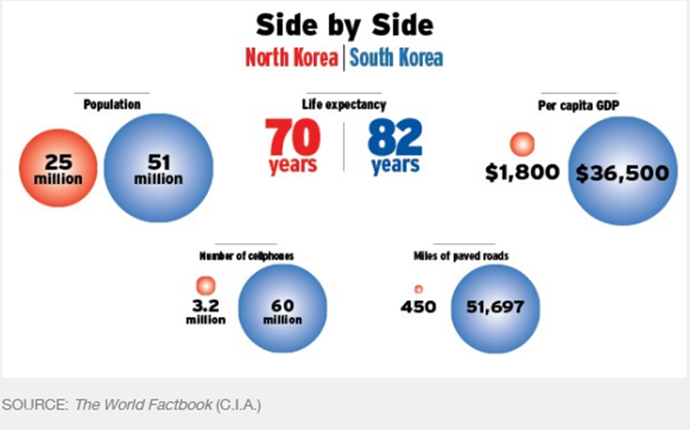
Escape from North Korea
Arriving in the U.S. at age 16, Joseph Kim was able to start over
Not long after Joseph Kim fled North Korea, missionaries in China offered him a chance at a new life in America. His first instinct was to say no.
“Growing up in North Korea, I was brainwashed that America is our nation’s enemy, that we have to destroy it,” he says.
He reconsidered when the missionaries explained he’d have the opportunity for a good education and that he’d be able to move around freely.
Within a few months, Joseph arrived as a refugee in Richmond, Virginia. When he started high school two weeks later, he didn’t speak any English, and he hadn’t attended any school since he was about 11 years old.
“It was very unsettling,” he recalls.
After flailing in the beginning, Joseph remembered how his father had urged him to study hard in elementary school. He decided to throw himself into his schoolwork to honor his father’s memory. Despite how far behind he was, he graduated from high school in four years with academic honors.
After two years at a community college in New York City, Kim transferred to Bard College, a prestigious school in upstate New York, where he’s now a junior studying international business. He hopes someday to work in foreign policy or with human rights groups. But mostly, he wants to help people in North Korea.
“I really believe that it will change,” he says of his homeland. “I don’t know how, whether it’ll be reunification or the collapse of the system. But I place my hope in ordinary North Korean people.”
—Patricia Smith

